ES0 203A INTRODUCTION to EE 27.1.17
TUT3

Q1. Find the expression for inductance of a pair of coupled coils connected in series with aiding and opposing polarity.
(a)
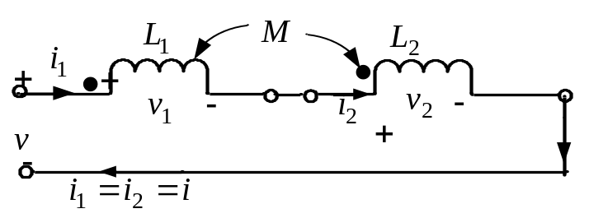
(b)
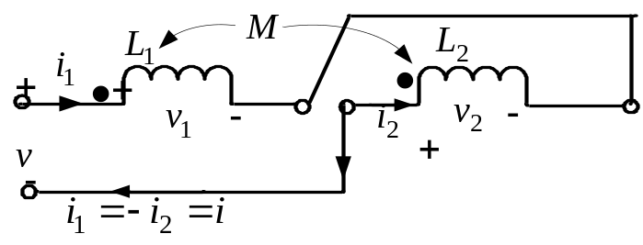
Ans:

Q2: Find the expression for inductance of a pair of coupled coils connected in parallel with aiding and opposing polarity.

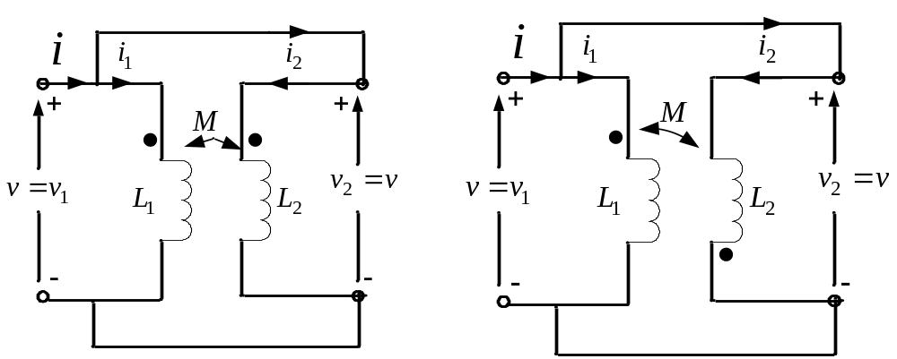
(a) (b)

Ans: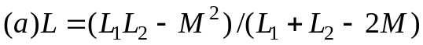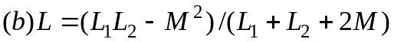

Q3: For the network shown, determine the expression for the input impedance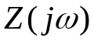.

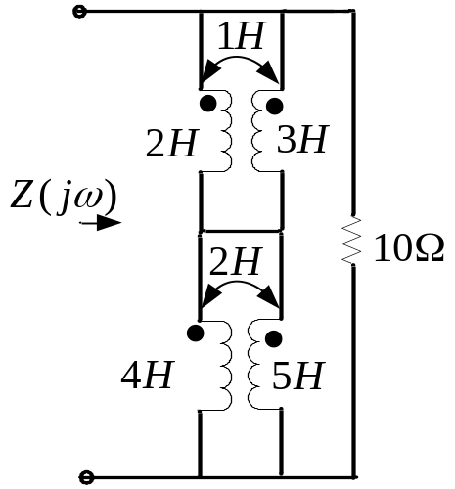

Ans: 